**DBMS PROJECT**

**TOPIC: EAPCET COUNSELLING SYSTEM**

  1) Abrarullah Haqqani (22EEB0A17)

                                                                                             2) Ishrat Ali Khan (22EEB0A21)

**Problem Statement:-**

In this project, we have designed a database management system to store and manage the information about a student's registration and counselling process for the EAPCET exam. The Database will contain important information about the students and will be accessible to counselling authorities and the student himself.

This database management system will help the student and the officials during the whole examination and counselling process, which will vary from admit card release to counselling result (seat allotment).

This Database will contain the students' details, exam details, result of the examination, choices filled during the counselling process and its corresponding results.

Our Database will provide complete transparency during the whole counselling process.

# Tables :-

Candidate

|  |  |  |
| --- | --- | --- |
| Attribute | Datatype | Constraints and Characteristics |
| Registration_No | VARCHAR(20) | Primary key |
| First_Name | VARCHAR(20) | Not null |
| Last_Name | VARCHAR(20) | Not null |
| Father_Name | VARCHAR(20) | Not null |
| Mobile_No | BIGINT | Not null |
| Email_Id | VARCHAR(20) | Not null |
| Address | VARCHAR(50) | Not null |
| Gender | VARCHAR(10) | Not null |
| DOB | date | Not null |
| Password | VARCHAR(20) | Not null |

Category

|  |  |  |
| --- | --- | --- |
| Attribute | Datatype | Constraints and Characteristics |
| Category_Id | VARCHAR(20) | Primary key |
| Category_Name | VARCHAR(20) | Not null, Unique |
| Total_Seats | INT | Not null |

Payment

|  |  |  |
| --- | --- | --- |
| Attribute | Datatype | Constraints and Characteristics |
| Transaction_Id | VARCHAR(20) | Primary key |
| Registration_No | VARCHAR(20) | Foreign key , Not null |
| Payment_Date | DATE | Not null |
| Payment_Time | time | Not null |
| Amount | BIGINT | Not null |

Admit_Card

|  |  |  |
| --- | --- | --- |
| Attribute | Datatype | Constraints and Characteristics |
| Roll_No | VARCHAR(20) | Primary key |
| Registration_No | VARCHAR(20) | Foreign key, Not null |
| Exam_Date | DATE | Not null |
| Exam_Start_Time | TIME | Not null |
| Exam_End_time | TIME | Not null |
| Centre_Id | VARCHAR(20) | Not null |

Centre

|  |  |  |
| --- | --- | --- |
| Attribute | Datatype | Constraints and Characteristics |
| Centre_Id | VARCHAR(20) | Primary key |
| Center_Name | VARCHAR(50) | Not null |
| Center_Address | VARCHAR(50) | Not null |
| Nearest_Metro_Station | VARCHAR(50) | Not null |
| City | VARCHAR(20) | Not null |

Result

|  |  |  |
| --- | --- | --- |
| Roll_No | VARCHAR(20) | Primary key, Foreign key |
| Marks | double(5,2) | Not null |
| Exam_Rank | BIGINT | Not null |
| Category_Id | VARCHAR(20) | Foreign key, Not null |

Cutoff

|  |  |  |
| --- | --- | --- |
| Attribute | Datatype | Constraints and Characteristics |
| Category_Id | VARCHAR(20) | Primary key, Foreign key |
| Cutoff_marks | Double(5,2) | Not null |

Counselling

|  |  |  |
| --- | --- | --- |
| Attribute | Datatype | Constraints and Characteristics |
| Reference_No | VARCHAR(20) | Primary key |
| Registration_No | VARCHAR(20) | Foreign key, Not null |
| Roll_No | VARCHAR(20) | Foreign key, Not null |
| Transaction_Id | VARCHAR(20) | Foreign key, Not null |

College

|  |  |  |
| --- | --- | --- |
| Attribute | Datatype | Constraints and Characteristics |
| College_Id | VARCHAR(20) | Primary key |
| College_Name | VARCHAR(50) | Not null |
| Metro_Stations | INT | Not null |
| College_Address | VARCHAR(50) | Not null |

Branch

|  |  |  |
| --- | --- | --- |
| Attribute | Datatype | Constraints and Characteristics |
| Branch_Id | VARCHAR(20) | Primary key |
| Branch_Name | VARCHAR(20) | Not null |
| No_of_seats | INT | Not null |

Choices

|  |  |  |
| --- | --- | --- |
| Attribute | Datatype | Constraints and Characteristics |
| C_Id | VARCHAR(20) | Primary key(1), Foreign key |
| B_Id | VARCHAR(20) | Primary key(2), Foreign key |

Choices_Filled

|  |  |  |
| --- | --- | --- |
| Attribute | Datatype | Constraints and Characteristics |
| Reference_No | VARCHAR(20) | Primary key(1), Foreign key |
| College_Id | VARCHAR(20) | Primary key(2), Foreign key(1) |
| Branch_Id | VARCHAR(20) | Primary key(3), Foreign key(2) |

Counselling_Result

|  |  |  |
| --- | --- | --- |
| Attribute | Datatype | Constraints and Characteristics |
| Reference_No | VARCHAR(20) | Primary key, Foreign key |
| College_Id | VARCHAR(20) | Foreign key(1), Not null |
| Branch_Id | VARCHAR(20) | Foreign key(2), Not null |

# Functional Dependencies and Primary Key –

1. Candidate –

Registration_No -> { First_Name,Last_Name, Father_Name, Mobile_No, Email_Id, Address, Gender, DOB,Password}

Since all the fields depend on Registration_No, (Registration_No)+ -> R. Hence, Registration_No is a Primary Key

1. Category –

Category_Id -> { Category_Name, Total_Seats}

Since all the fields depend on Category_Id, (Category_Id)+ -> R.

Hence, Category_Id is a Primary Key

1. Centre –

Centre_Id -> { Centre_Name,Center_Adress, City }

Since all the fields depend on Centre_Id, (Centre_Id)+  -> R. Hence,Centre_Id is Primary Key.

1. Admit_Card –

Roll_No -> { Registration_No, Exam_Date, Exam_Start_Time, Exam_End_Time, Centre_Id } RegistrationNumber -> { Roll_No, Exam_Date, Exam_Start_Time, Exam_End_Time,Centre_Id }

Since all the fields depend on Roll_No, (Roll_No)+ -> R.

Hence, Roll_No is a Primary Key

1. Cutoff –

Category_Id -> {Cutoff_marks}

Since all fields depend on Category_Id, (Category_Id)+ -> R.

Hence, Category_Id is Primary Key.

Result –

Roll_No -> { Marks, Exam_Rank, Category_Id }

Since all fields depend on Roll_No, (Roll_No)+ -> R.

Hence, Roll_No is Primary Key.

7) Payment –

Transaction_Id -> { Registration_No, Payment_Date, Payment_Time, Amount } RegistrationNumber -> { Transaction_Id, Payment_Date, Amount}

Since all the fields depend on Transaction_Id, (Transaction_Id)+ -> R.

Hence, Transaction_Id is a Primary Key

8) Counselling –

Reference_No -> { Registration_No, Roll_No, Transaction_Id } Registration_No -> { Reference_No, Roll_No, Transaction_Id } Roll_No -> { Registration_No, Reference_No, Transaction_Id } Transaction_Id -> { Registration_No, Roll_No, Reference_No }

Since all fields depend on Refrence_No, (Reference_No)+ -> R.

Hence, Reference_No is Primary Key.

9) College –

College_Id -> { College_Name, College_Address, Metro_Stations }

Since all the fields depend on College_Id, (College_Id)+ -> R.

Hence, College_Id is Primary Key.

10) Branch –

Branch_Id -> { Branch_Name, No_of_seats }

Since all the fields depend on Branch_Id, (Branch_Id)+ -> R.

Hence, Branch_Id is Primary Key.

11) Choices –

{ College_Id, Branch_Id } -> { - }

Since all attributes are part of key, ( { College_Id, Branch_Id } )+ -> R.

Hence, { College_Id, Branch_Id } is Primary Key.

12) Choices_Filled –

{ Reference_No, College_Id, Branch_Id } -> { - }

Since all attributes are part of key, ( { Reference_No, College_Id, Branch_Id } )+ -> R. Hence, { Reference_No, College_Id, Branch_Id } is Primary Key.

13) Counselling_Result –

Reference_No -> { College_Id, Branch_Id }

Since all the fields depend on Reference_No, (Reference_No)+ -> R. Hence, Reference_No is Primary Key.

# Normalization –

1. Candidate

Primary key : Registration_No

All attributes depend on the Registration_No, hence the table is in 2NF.

All attributes depend directly on Registration_No, hence the table is in 3NF.

All determinants ( Registration_No ) is Super key, hence the table is in BCNF.

1. Category

Primary key: Category_Id

All attributes depend on the Category_Id, hence the table is in 2NF.

All attributes depend directly on Category_Id, hence the table is in 3NF.

All determinants ( Category_Id ) is Super key, hence the table is in BCNF.

1. Centre

Primary key: Centre_Id

All attributes depend on the Centre_Id, hence the table is in 2NF.

All attributes depend directly on Centre_Id, hence the table is in 3NF.

All determinats ( Centre_Id ) is Super key, hence the table is in BCNF.

Payment

Primary key: PaymentID

All attributes depend on the PaymentID, hence the table is in 2NF.

All attributes depend directly on PaymentID, hence the table is in 3NF.

All determinants ( PaymentID ) is Super key, hence the table is in BCNF.

4) Admit_Card

Primary key: Roll_No

All attributes depend on the Roll_No, hence the table is in 2NF.

All attributes depend directly on Roll_No, hence the table is in 3NF.

All determinats ( Roll_No ) is Super key, hence the table is in BCNF.

5) Cutoff

Primary key: Cutoff_Id

All attributes depend on the Cutoff_Id, hence the table is in 2NF.

All attributes depend directly on Cutoff_Id, hence the table is in 3NF.

All determinats ( Cutoff_Id ) is Super key, hence the table is in BCNF.

6) Result

Primary key: Roll_No

All attributes depend on the Roll_No, hence the table is in 2NF.

All attributes depend directly on Roll_No, hence the table is in 3NF.

All determinats ( Roll_No ) is Super key, hence the table is in BCNF.

7) Payment

Primary key: Transaction_Id

All attributes depend on the Transaction_Id, hence the table is in 2NF.

All attributes depend directly on Transaction_Id, hence the table is in 3NF.

All determinants ( Transaction_Id ) is Super key, hence the table is in BCNF.

1. Counselling

Primary key: Reference_No

All attributes depend on the Reference_No, hence the table is in 2NF.

All attributes depend directly on Reference_No, hence the table is in 3NF.

All determinats ( Reference_No, Registration_No, Roll_No, Transaction_Id) is Super key, hence the table is in BCNF.

1. College

Primary key: College_Id

All attributes depend on the College_Id, hence the table is in 2NF.

All attributes depend directly on College_Id, hence the table is in 3NF. All determinants ( College_Id ) is Super key, hence the table is in BCNF.

1. Branch

Primary key: Branch_Id

All attributes depend on the Branch_Id, hence the table is in 2NF.

All attributes depend directly on Branch_Id, hence the table is in 3NF. All determinats ( Branch_Id ) is Super key, hence the table is in BCNF.

1. Choices

Primary key: { College_Id, Branch_Id }

All attributes are part of Primary key, hence the table is in 2NF as well as 3NF.

All determinats ( {College_Id, Branch_Id} ) is Super key, hence the table is in BCNF.

1. ChoicesFilled

Primary key: { Reference_No, College_Id, Branch_Id }

All attributes are part of Primary key, hence the table is in 2NF as well as 3NF.

All determinats ( {Reference_No, College_Id, Branch_Id} ) is Super key, hence the table is in BCNF.

1. CounsellingResult

Primary key: Reference_No

All attributes depend on the Reference_No, hence the table is in 2NF.

All attributes depend directly on Reference_No, hence the table is in 3NF. All determinats ( Reference_No ) is Super key, hence the table is in BCNF.

ER DIAGRAM:

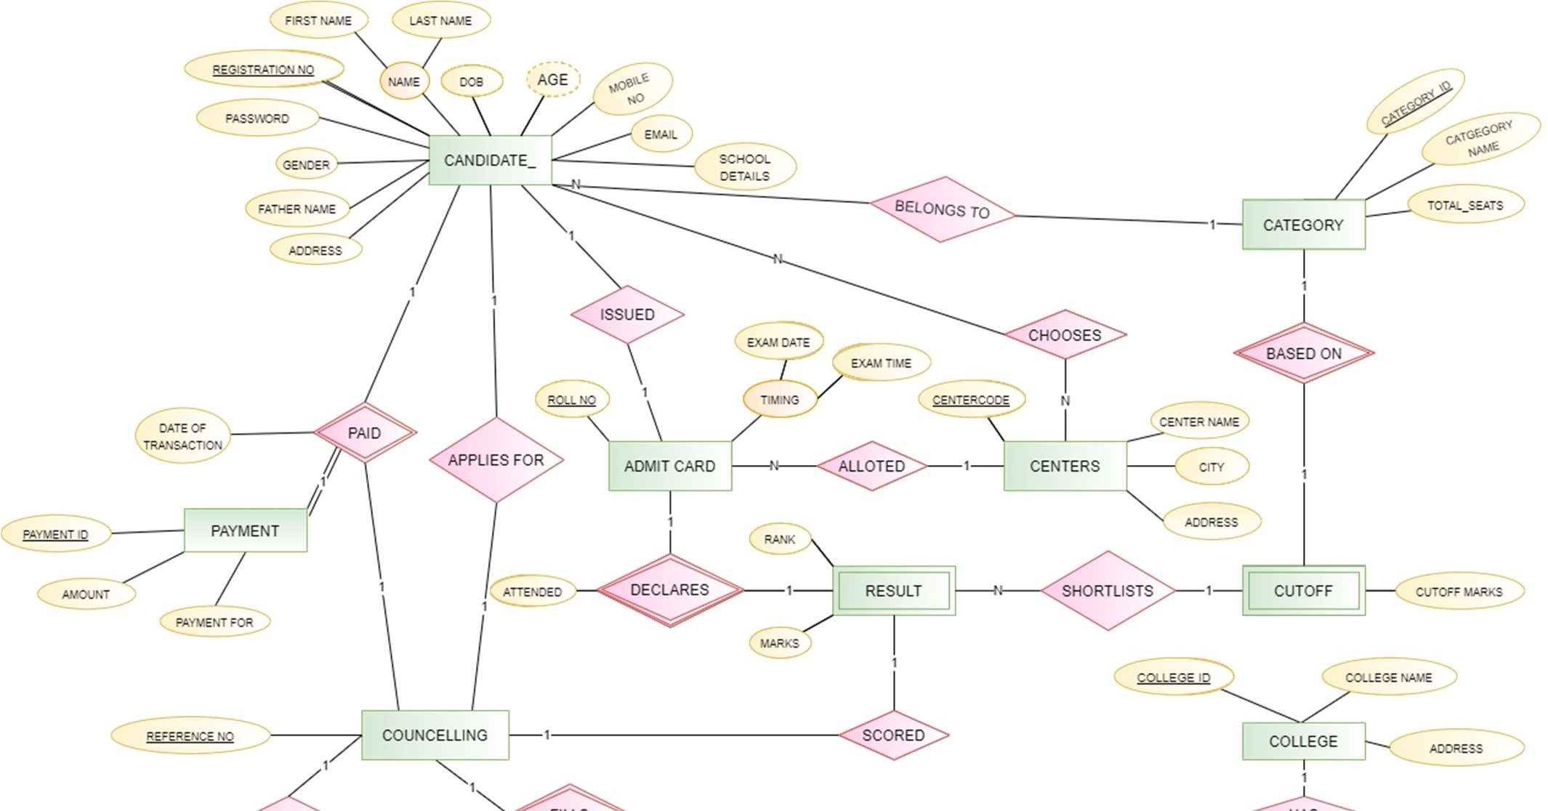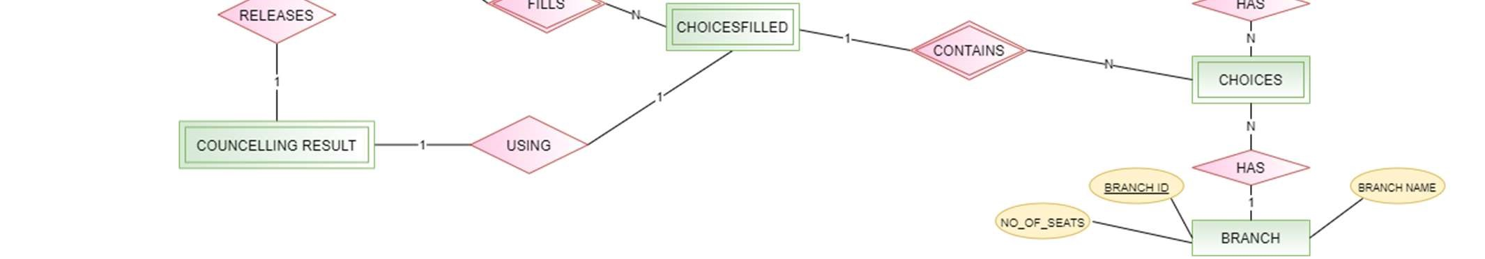

Relational Schema with Normalised Tables:

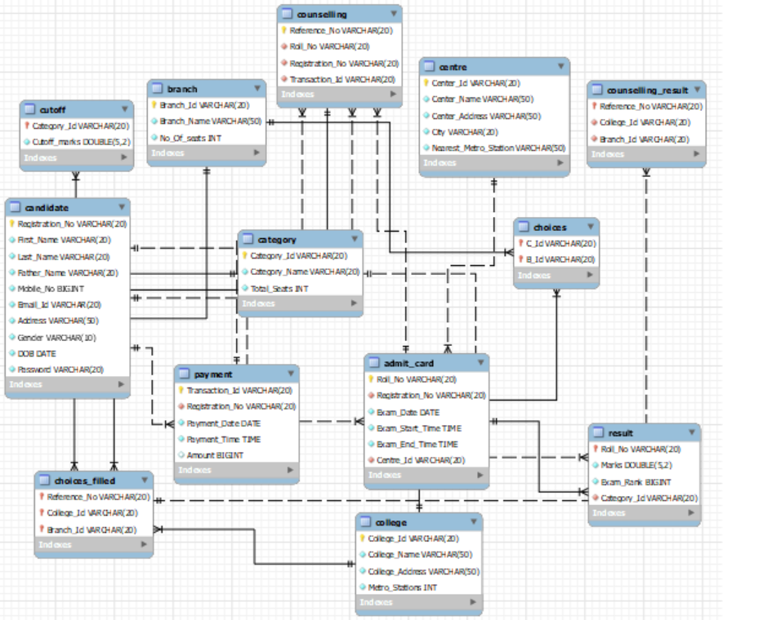

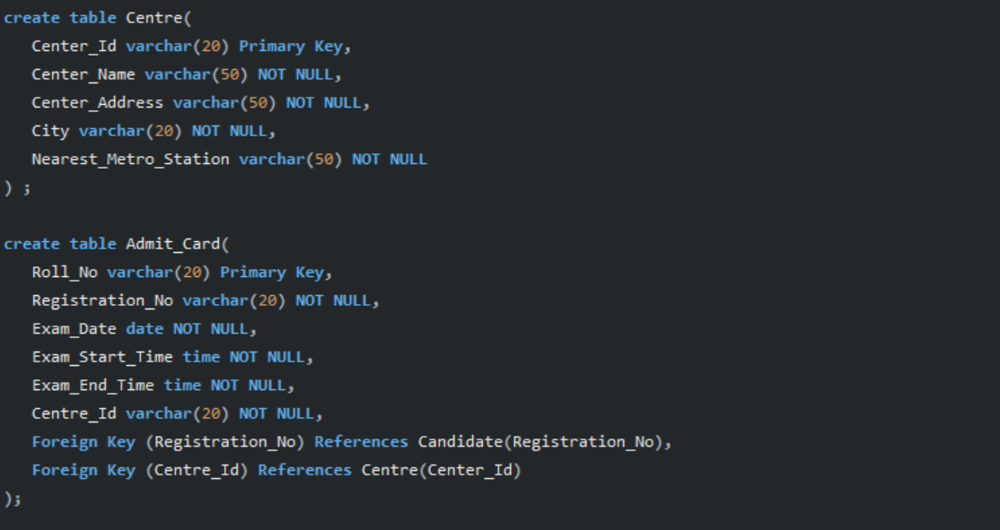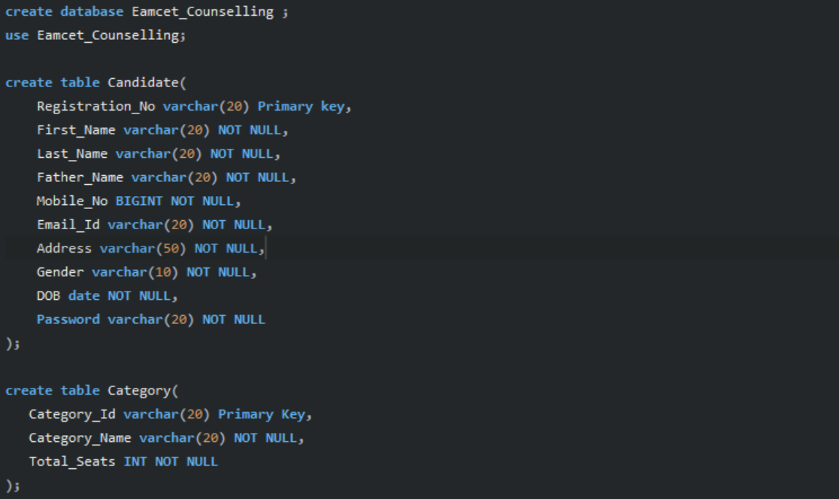

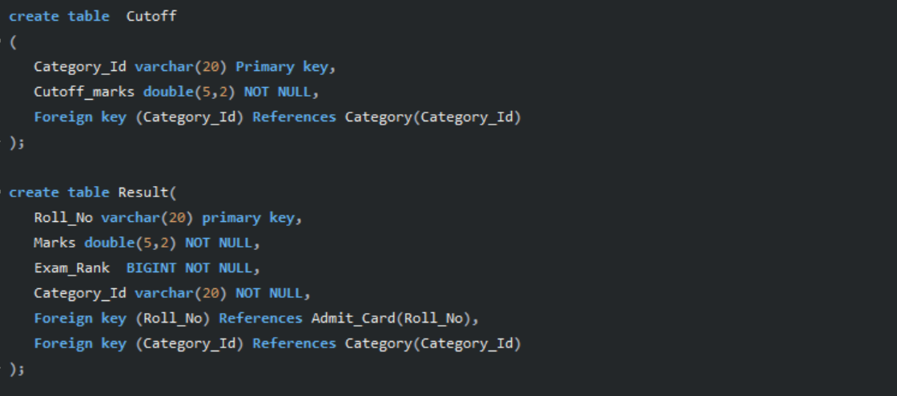

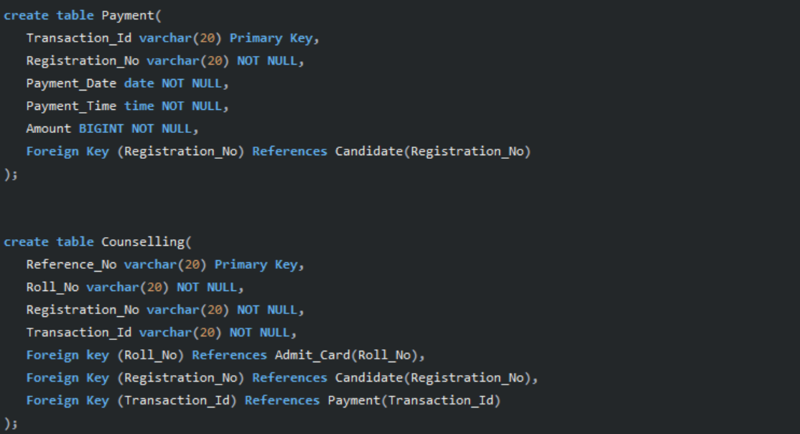

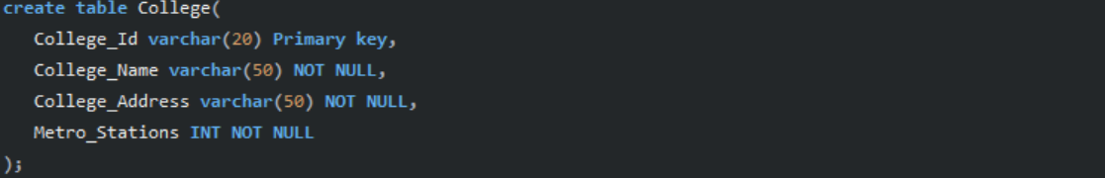

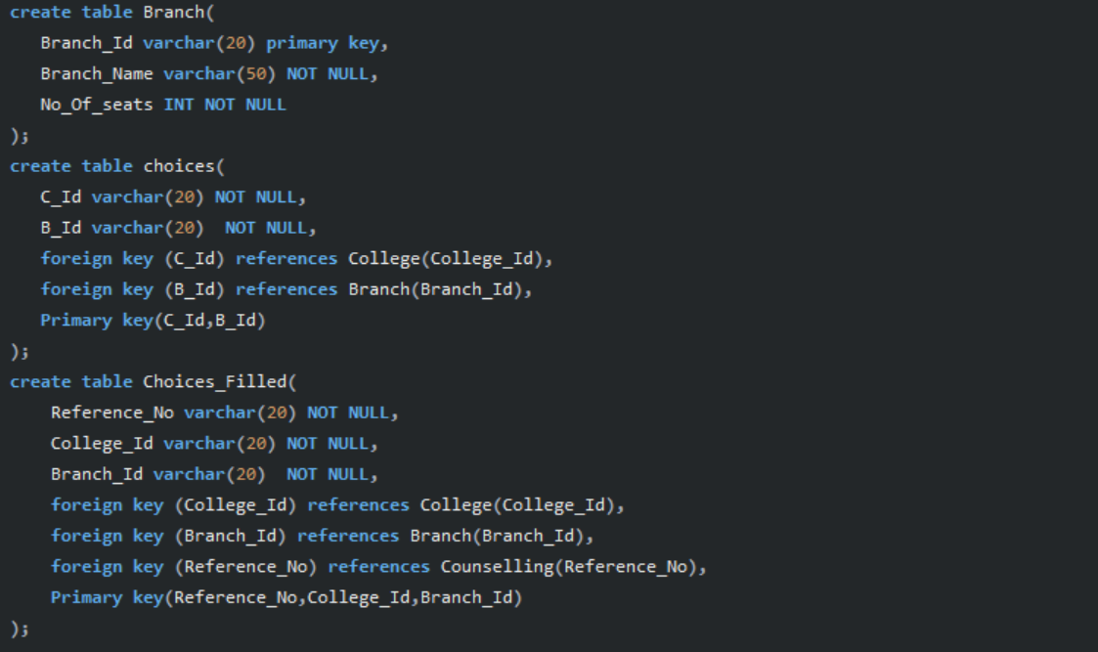

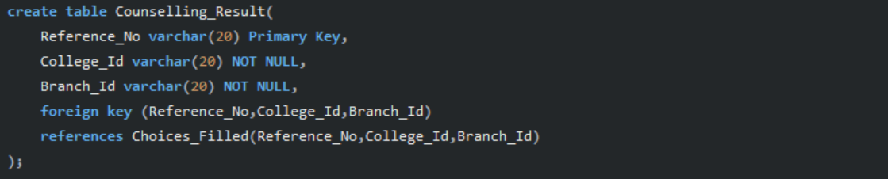

TABLE INSERTION:

1. Candidate

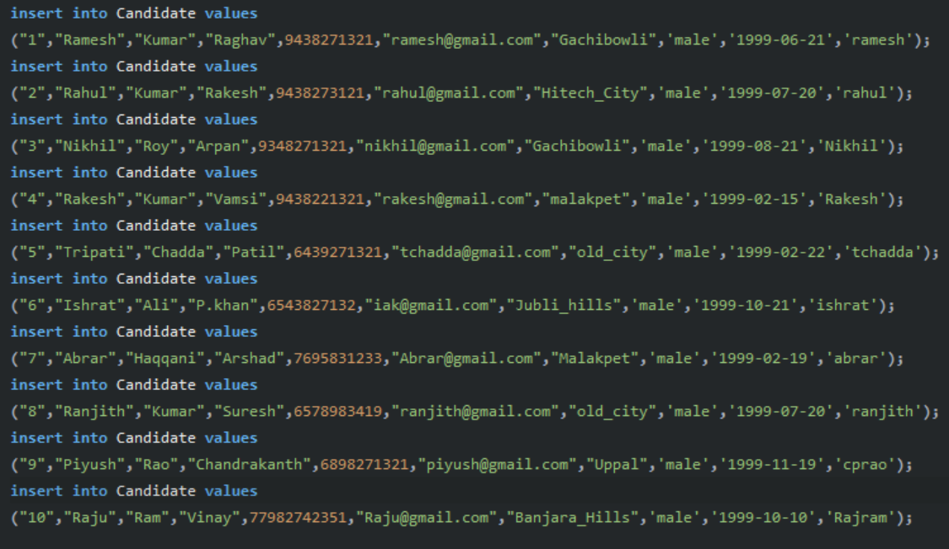

# CATEGORY

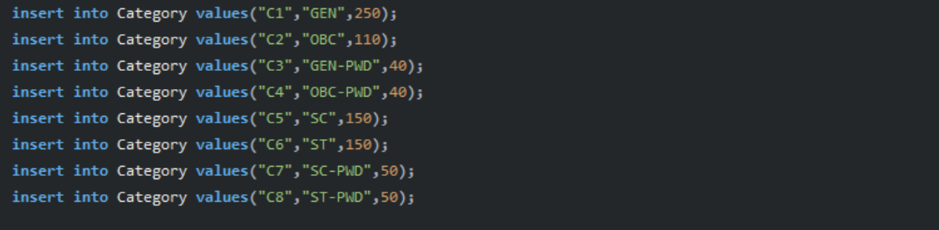

# BRANCH

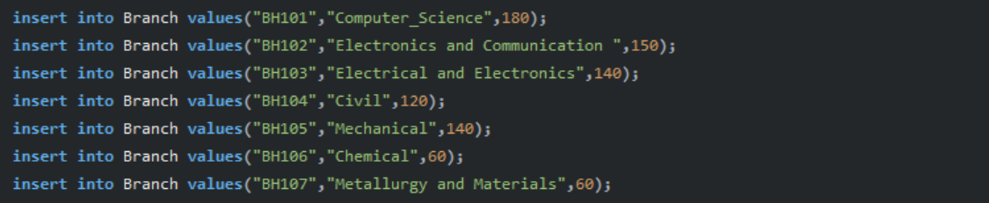

# CENTRE

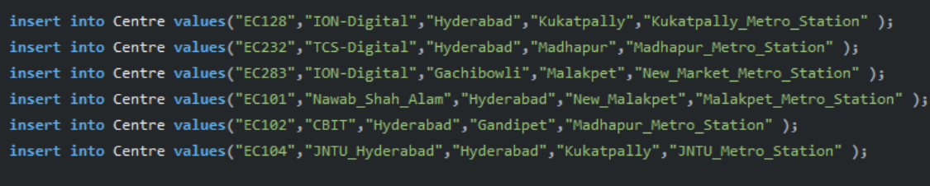

# COLLEGE

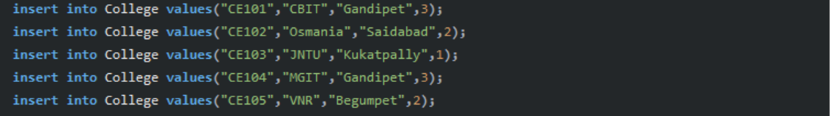

# PAYMENT

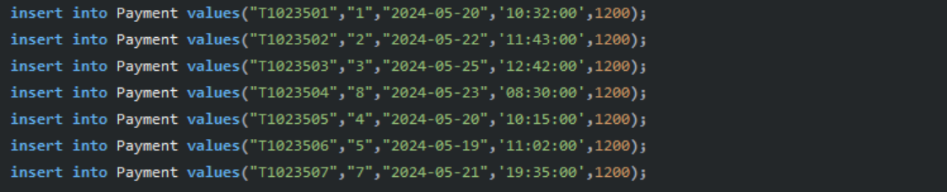

# ADMIT_CARD

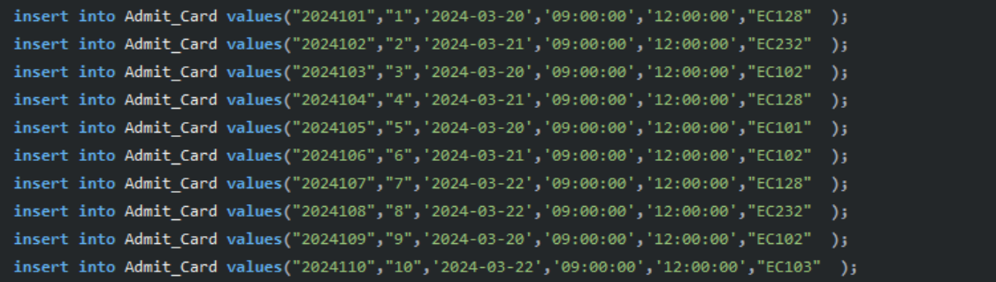

# CUTOFF

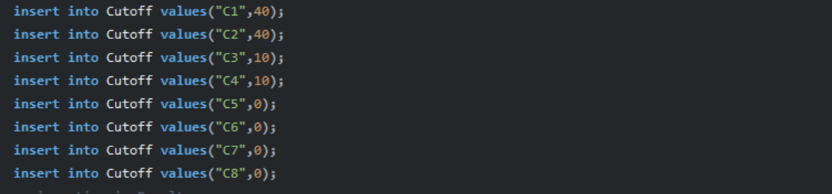

# RESULT

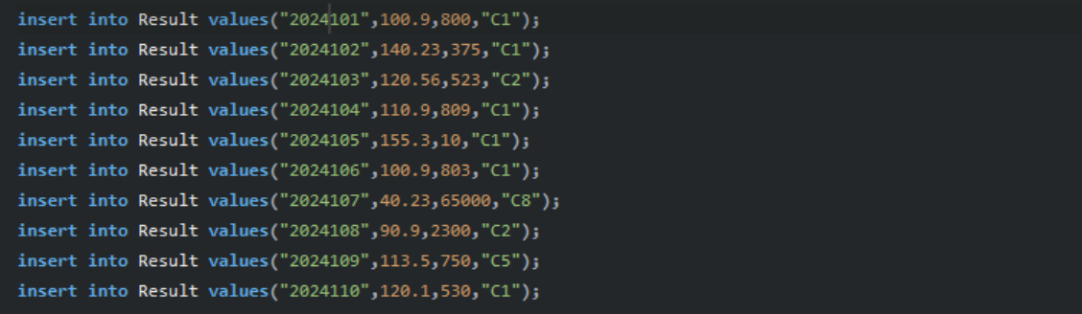

# COUNSELLING

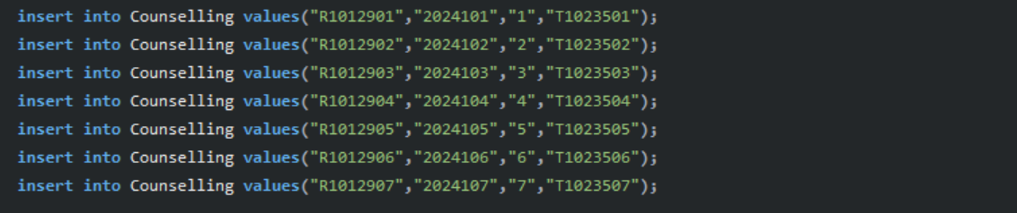

# CHOICES

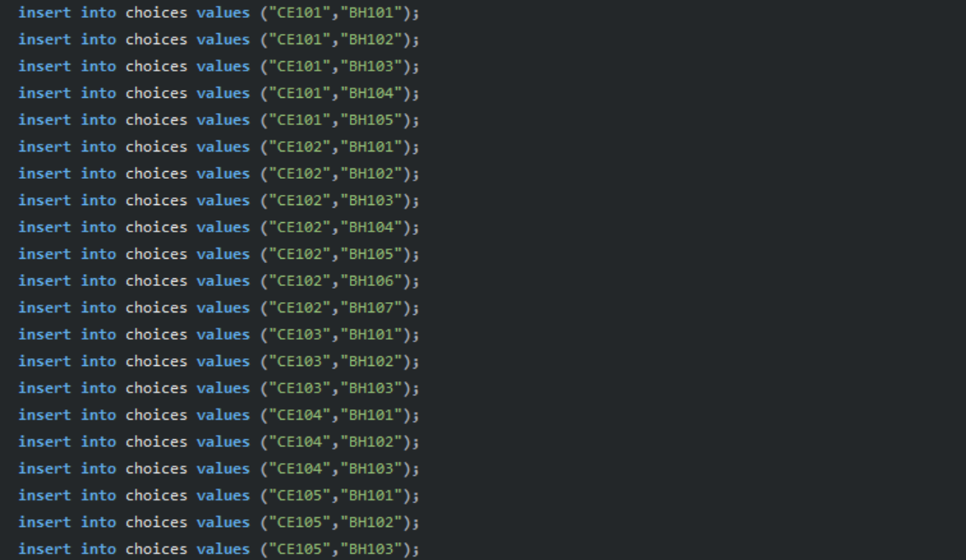

# 12. CHOICESFILLED

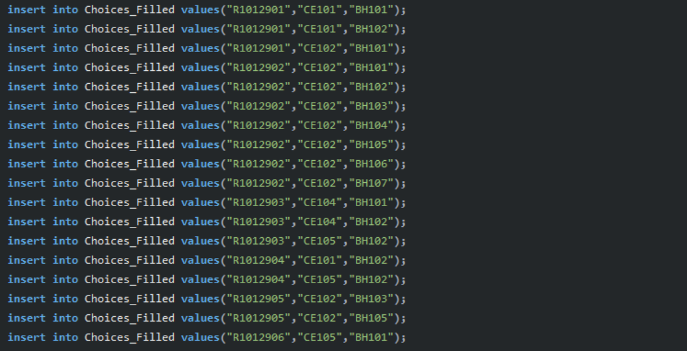

# COUNSELLINGRESULT

# 

# THANK YOU

1. ABRARULLAH HAQQANI 22EEB0A17
2. ISHRAT ALI KHAN 22EEB0A21